Nothing in moderation – Zsuzsa and her journey…..to date
Running has always been my nemesis. For many years now my aim has been to run a marathon but I always sustain some sort of injury. In January 2021 I had one of the most serious injuries, a stress fracture in one femur and a stress reaction in the other... The reason for this was mainly that I had become impatient and ran too much week after week. So, in the middle of the winter AND the pandemic, when there was hardly any sport activity that I was allowed to do anyway, I lost running as well for the following 5 months. I must admit I became very sad and slightly depressed. That is why I was so happy to see that swimming pools were opening up, albeit only for 45-minute sessions. I threw myself into swimming, as I do, and very soon found myself going 4-5 times a week.

I could not increase the distance, however, as these sessions were limited to 45 minutes and anyway, it was getting slightly boring doing 90 lengths every time, there and back and there and back... I was desperate to find a different venue, to swim longer or just to make it more interesting. 🙂 And that is when I found The Lake! How I have not contacted the club before is a mystery to me, seeing that I live so close to the Lake at the Bridge. The rest is history as they say.

I was scared to start with when I thought about how much water is below me (who cares when you swim on the surface of it???) but that went away fairly quickly. As I do nothing in moderation, I signed up to various open water courses over the summer: I went to the Lake District, swam in the River Cam and attended a sea swimming course for beginners near Brighton.

The fact that I could swim longer at any one time AND in a setting that was brand new to me was amazing. I enjoyed it soooo much that I set my eyes on doing longer distances and finally I attended an event in Hungary that I have been meaning to do for 3 years. This specific event is very close to my heart as it is held in a town where my Grandparents used to live and I spent many a happy summer holiday there. This is a 24-hour event during which time somebody always needs to be swimming. The longest I have swum up to that point was 6 kilometres. I committed to swim 10 kilometres, which I duly delivered. Out of all the participants I swam the second longest distance, which I was very proud of.
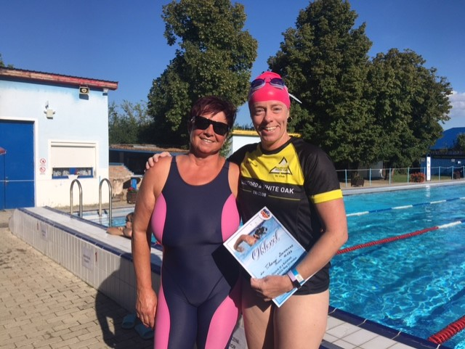

The confidence I got by swimming in OUR (🙂) lake allowed me to sign on to the Dock2Dock where I also swam 10 kilometres. It was cold and took me 3:34 to complete and the last 1500 metres were just really hard but I was so proud when I completed it!

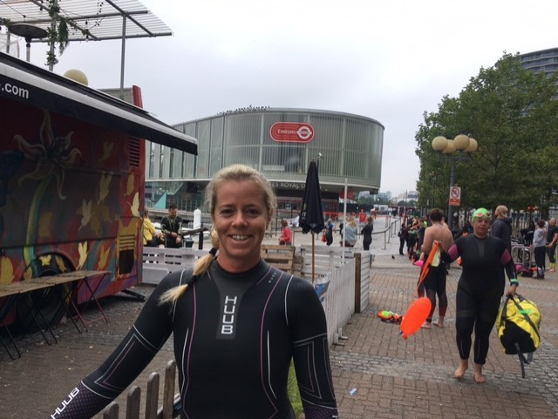

One of the best things that has happened this year was getting into open water swimming and I am very grateful for the Club for all their help and the encouraging words, it is all truly appreciated. the best thing about swimming is that at least I cannot break any bones. 🙂
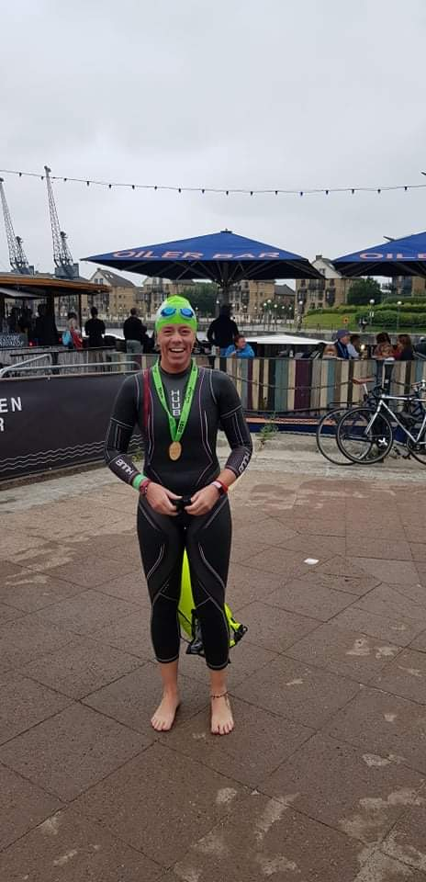

But now that the Lake is closed, what do I do? Well. Keep up the swimming AND get back into running, it is about time! Maybe I can run the Bridge Marathon next year? Fingers crossed. 🏅

